Create Table: Apply What You Have Learnt !
Send Feedback

Tables are a great way to display data in a tabular form. It simplifies the way we look at the data.

It is now time for us to create a simple table for the use of Coding Ninjas.

So, create a table using the image of the visualization chart provided below. Also, a small boilerplate code for starting with the table is provided.

If you get confused somewhere, you can also take help from the image of the table provided below.

The visualization chart is -

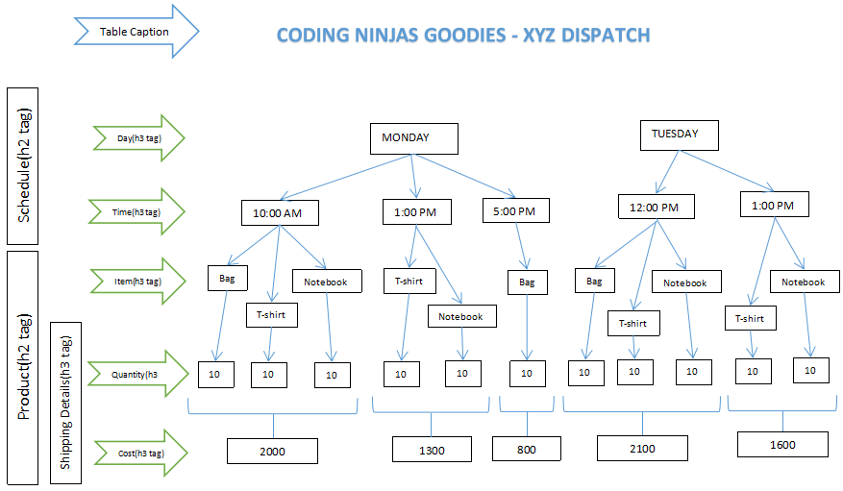

The table should look like this -

